**Picture Lab**

**A3: Exploring a picture**

Run the main method in PictureExplorer.java. This will load a picture of a beach from a file, make a copy of that picture in memory, and show it in the explorer tool (Figure 3). It makes a copy of the picture to make it easier to explore a picture both before and after any changes. You can use the explorer tool to explore the pixels in a picture. Click any location (pixel) in the picture and it will display the row index, column index, and red, green, and blue values for that location. The location will be highlighted with yellow crosshairs. You can click on the arrow keys or even type in values and hit the enter button to update the display. You can also use the menu to change the zoom level.

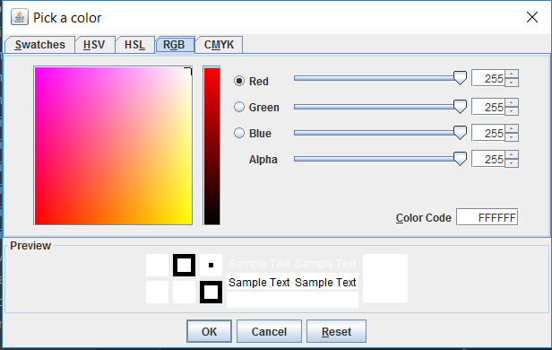

Figure 2: The Color Chooser

When you click the OK button, the red, green, and blue values for the color you picked will be displayed as shown below. The Color class has a toString method that displays the class name followed by the red, green, and blue values. The toString method is automatically called when you print an object.

**java.awt.Color[r=139,g=174,b=255]**

Picture class contains the following import statement.

**import java.awt.Color;**